1. **Agenda:**
   1. What is Mutex?
   2. What are differences b/w semaphore and mutex?
   3. What are similarities b/w them?
2. 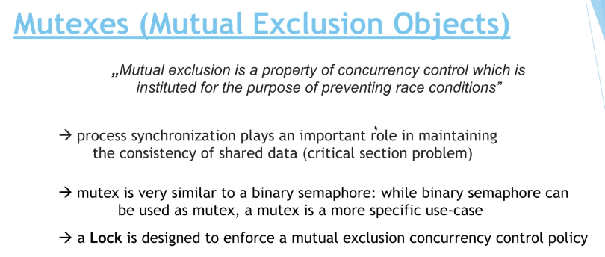
3. 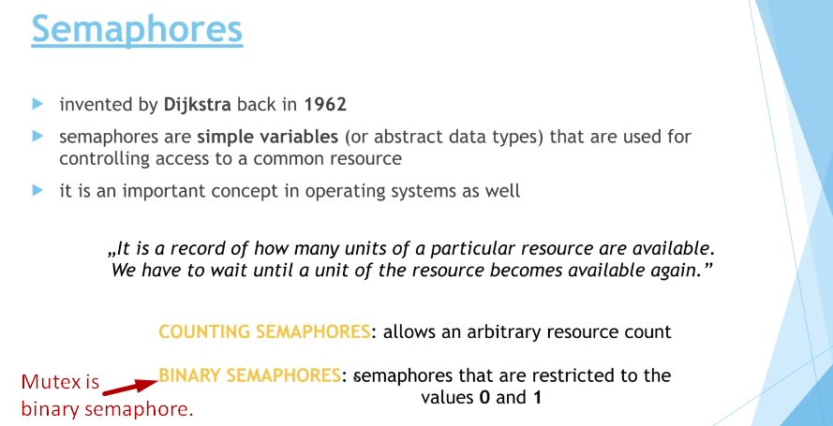
4. Actually a lock is mutex used to prevent **Race-Condition**.
5. 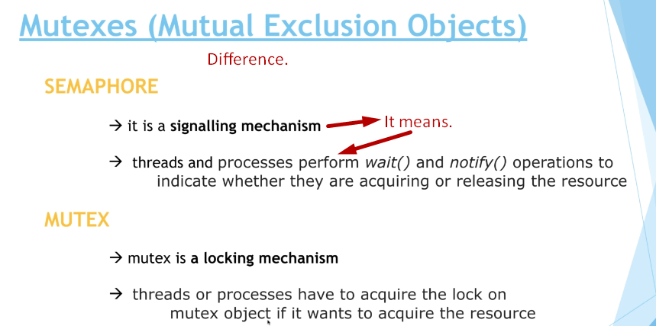
6. 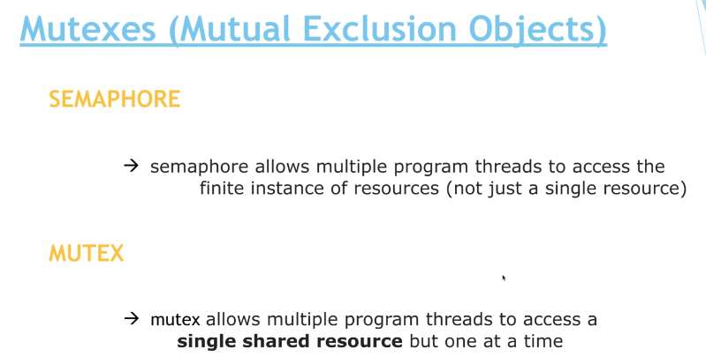
7. 